MODY pathway as prognosis Marker for esophageal adenocarcinoma
Abstract
Backgound: Esophageal carcinoma is 8th top cancer. In 2020 it caused 604,100 new cases. But there was no biomarker that can associate with tissue and prognosis simultaneously. Methods: Differentially expressed genes was first screened followed by functional enrichment. GSVA was applied to identify the survival-related pathway. SVM classifier was used to classify the EAC samples. Results: Glycan processing pathway and MODY (Maturity Onset Diabetes of the Young) pathway were enriched. Six genes (HNF4G, HNF4A ,PDX1, NEUROG3, RFX6 and PAX4) was filtered as a poor-progonosis risk factor. They associated with progonosis in univariate Cox regression (P-value 0.0432, HR 1.98, 95% CI. 1.02-3.84) and multivariate Cox regression (P-value 0.0277, HR 4.03, 95% CI. 1.16-14.0) and the performance as a EAC universal histology biomarker is AUC 0.952 (TCGA cohort) and was verified as AUC 0.944 in four independent GEO datasets. Conclusion: In this study we identified six genes in MODY pathway were uniformly up-regulated in EAC cases and associated with prognosis. The result indicates the glycan processing of mucins and foregut epithelium development were involved in carcinogenesis of EAC. It supports that the EAC progenitor cells are multi-originated. The jejunal progenitor cells and gastric epithelial cells can both follow a "migration-differentiation" model as possible origins of EAC.
Keywords: aaaaaaaaaa

Introduction
Esophageal carcinoma is 8th top cancer over the world. In 2020 it caused 604,100 new cases accounting for 3.1 percent of total cancer cases following cervix uteri carcinoma [ref1: https://gco.iarc.fr/today/data/factsheets/populations/160-china-fact-sheets.pdf]. China is an esophageal cancer high risk country. Since 2020 esophageal carcinoma has become the fifth common cancers following liver cancer in China. It has 324,422 new incidence in 2020 and take up to 7.1% of total cancer cases in that year. Incidence rate is more than twice than world average [Cancer Country Profile 2020 China].

The esophageal carcinoma has two common histology forms: esophageal squamous cell carcinoma (ESCC) and esophageal adenocarcinoma (EAC). They are named after the type of the cells that turn malignant. EAC is usually formed in the lower part of the esophagus near the stomach. Although various risk factors had been identified for EAC such as Helicobacter pylori infection and gastroesophageal reflux disease (GERD), the mechanisms of EAC pathogenesis is still unclear. There are some four hypothesis about origin of EAC progenitor cells. 1) native esophagus cells including basal cells of the squamous epithelium or cells of esophageal submucosal glands 2) specialized populations of cells from esophagogastric junction (EGJ) 3) progenitor cells from gastric cardia that migrate into the esophagus 4) progenitor cells from bone marrow transported through the blood [10.1053/j.gastro.2019.03.072].

Nowadays Circulating Tumor Cells (CTC) are under searchlight as novel target for liquid biopsy. Combined with qPCR or single-cell sequencing it has the potential for diagnosing pan-cancer in µl blood. By using proper markers not only could the types of cancer be recognized but the other clinic features such as histology types, prognosis etc. could also be identified. There are many researchers concentrating study on EAC biomarker for early-stage detection, prognosis or drug sensitivity. Nonetheless because no solid consensus on the origin of EAC tumor cells has been concluded until now all the identified biomarkers leads to three drawbacks. 1) There's no universal tissue-sepcific biomarker for EAC. 2) No biomarkers were identified simultaneously for early-stage detection and prognosis 3) Most of marker sets have priori association with expected clinic features before selection or were even extracted purely by statistically feature selection so they lack of the explanation on tumor cytoembryology mechanism.

In this study we first screened the differentially expressed genes (DEGs) followed by function enrichment analysis in order to identify tumor related pathway or functional modules. Next GSVA was applied on each modules to its calculate the enrichment score. The score was used to verify its correlation with patients survival and train a support vector machine model as a classifier to classify the unknown cases. Finally the performance of classifier on EAC was evaluated and validated on four independent GEO datasets. As results we identified six genes (HNF4G, HNF4A ,PDX1, NEUROG3, RFX6 and PAX4) in MODY (Maturity onset diabetes of the young) pathway were uniformly up-regulated in EAC cases and associated with tumor histology types and prognosis of EAC patients. This results also raise a new assumption that the EAC progenitor cells could originate from multiple organs including foregut(intestine) and gastric mucosa.

Methods and Material

Cohort selection
Initially the marker mining work uses TCGA esophageal carcinoma (ESCA) dataset as discovery cohort. The 88 EAC (79 tumor and 9 normal) cases with normalized gene expression (pancan normalized) was downloaded from USCS Xena [10.1038/s41587-020-0546-8]. We also used four GEO datasets (GSE155186, GSE165252, GSE44021, GSE112926) to validate the performance of six genes as EAC tissue-specific biomarker.

DEGs analysis and pathway enrichment
We downloaded the HTSeq-counts data from Xene Hub and shipped them into DESeq2 [10.1186/s13059-014-0550-8]. Because we are only interested in up-regulated genes in EAC those with an adjusted P-value <0.01 and log2 foldchange (FC) > 1 were considered as DEGs. gprofiler2 [10.1093/nar/gkz369] was used to perform GO functional and KEGG pathway analysis of the common DEGs. And the GO functional analysis of integrated DEGs refers to three parts: biological process (BP), cell component (CC), and molecular function (MF). FDR < 0.01 was considered to have a statistically significant difference. The enrichment score for each case was calculated by GSVA [10.1186/1471-2105-14-7]. The clustering of EAC cases was carried out by ConsensusClusterPlus [10.1093/bioinformatics/btq170]. The heatmap plot was drawn by ComplexHeatmap [10.1093/bioinformatics/btw313].

Discovery and validation of tissue-specific biomarker
We applied support vector machine model in evaluating and validating the performance of biomarker according to AUC and F1 score by scikit-learn [https://github.com/scikit-learn/scikit-learn]. A 100-fold stratified shuffle data split was done as cross validation. The optimal GSVA score cutoff was calculated by R maxstat.

Survival analysis and visualization
Using the R package survival [10.1007/978-1-4757-3294-8], the univariate and multivariate Cox regression analyses were performed for analyzing associations of GSVA score of MODY pathway with overall survival. Based on the cutoff of GSVA scores, all patients were divided into high- and low- risk group. We used Kaplan–Meier curves to exhibit the association between GSVA score and overall survival. The log-rank test was employed to test the statistic difference with the significance level p < 0.05.

Results

Cohort information
All TCGA data including gene expression matrix, survival and phenotype data was downloaded from UCSC Xena GDC hub [10.1038/s41587-020-0546-8]. We only extracted from esophageal cancer RNAseq cohort the cases that were marked as adenocarcinomas in their phenotype disease type. Totally 79 EAC tumor and 9 normal cases were identified and the other clinical information was displayed in table 1. This expression data will be used as discovery cohort and compared with corresponding data from other 32 TCGA projects and 10884 cases (supplementary table QHcvWCNT). We applied differential expressed gene analysis on HTSeq-Counts data as it was unnormalized raw counts and FPKM was used to compare gene expression between cases and genes after robust z-score normalization. Four GEO datasets (GSE155186, GSE165252, GSE44021, GSE112926) were used as validation cohort. Totally it contains 128 EAC cases and 139 ESCC cases.
Table 1 Clinical features of patients with EAC in TCGA esophageal carcinoma cohort
Clinical features | Tumor count (%) (n = 79)
Age (year)
Min. | 27
Median | 68
Max. | 86
Gender
Male | 68 (86.1%)
Female | 11 (13.9%)
Barrett's esophagus
Yes | 26 (32.9%)
No | 47 (59.5%)
Not recorded | 6 (7.6%)
Lymph metastasis
Yes | 24 (30.3%)
No | 48 (60.8%)
Not recorded | 7 (8.9%)
Survival records
Dead | 39 (49.4%)
Alive | 40 (50.6%)
Stage
I | 9 (11.4%)
II | 22 (27.8%)
III | 27 (34.2%)
IV | 5 (6.3%)
Not recorded | 16 (20.2%)

MODY module is poor prognosis factor in EAC
Kim et al. discovered that the EAC cases could be clustered into three groups according to mRNA expression and those EAC subgroups has association on disease-free survival [10.1371/journal.pone.0015074]. We failed to observe such connection in 79 EAC cases for TCGA project. There are no significant sub-types on mRNA expression alone. (supplementary figure 8wj8qwNA)

In order to find the specific function modules activated in EAC but not in the other types of cancers not only did we the differential expression analysis between these tumor and it paired normal samples, such analysis was also performed on each other cancer type against EAC. Using the DESeq2 we identified the 4464 up-regulated DEGs (differential expressed genes) for EAC against 33 other types of cancers. Although EAC and ESCC both belong to esophageal cancers family we can see the EAC and ESCC has quite different expression profile. For ESCC the activated function or pathway are primarily focused on keratinization and epidermis/epithelium development (data not shown) however when function enrichment was applied on each groups we characterized that the DEGs were mainly enriched in the glycan processing related pathway especially the mucins expression and maturity onset diabetes of the young (MODY, KEGG04950) (Figure and supplementary table e3hjfYYW). Many MUC family genes including MUC17, MUC3A and MUC4 etc. were up-regulated and overexpressed in EAC cases (supplementary figure nrqCvtnk). While six genes (PDX1, PAX4, HNF4G, HNF4A, NEUROG3 and RFX6) in MODY pathway were also up-regulated. Further we found that HNF4A/G and PDX1 shared a similar expression pattern while NEUROG3, RFX6 and PAX4 correlated to each other in another one (supplementary figure xhGxv2WN).
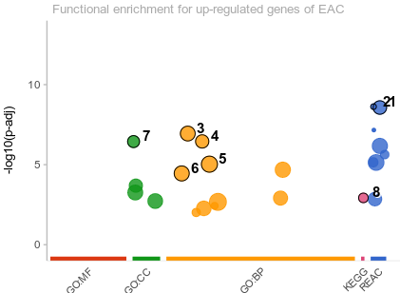
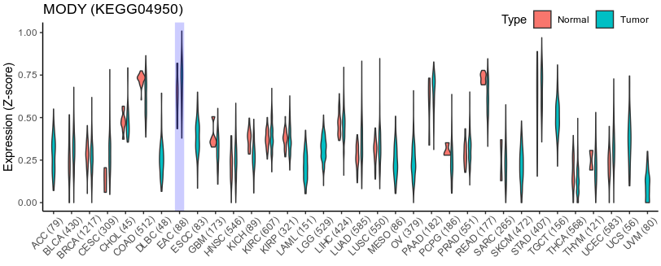
Figure e3hjfYYW Top: Functional enrichment results for up-regulated genes in EAC cases. 1. O-linked glycosylation of mucins 2. Defective C1GALT1C1 causes Tn poly-agglutination syndrome (TNPS). 3. digestion 4. O-glycan processing 5. antimicrobial humoral response 6. protein O-linked glycosylation 7. cornification envelope. 8. Maturity onset diabetes of the young. Bottom: The mean expression of six genes in MODY pathway (KEGG04950) . Y axis is the normalized Z-score of the expressionThe number in x-axis was the total case count including tumor and normal cases.

To provide insights into the relations of regulated modules and patients prognosis we calculated the GSVA score of up-regulated genes in each function modules to confirm if any genes with similar function could affect patients survival. We failed to observe any the association between EAC patients survival time and the enrichment of any glycan processing related pathway. The only prognosis related function module is MODY pathway. Six genes (PDX1, PAX4, HNF4G, HNF4A, NEUROG3 and RFX6) in this pathway were uniformly up-regulated in EAC cases and according to the results of uni- or multivariate Cox regression the GSVA score of MODY pathway was significantly associated with overall survival (p < 0.05 for each comparison). (Figure wuPAgSGL Table r2244YHs)
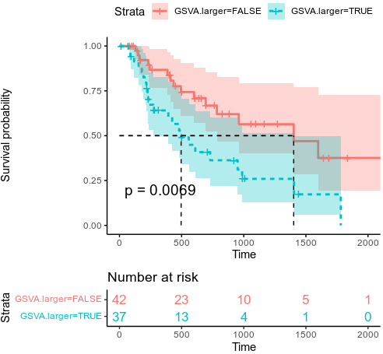
Figure wuPAgSGL The Kaplan-Meier survival curves of of EAC patients with low (pink) vs. high GASV score (cyan)

Table r2244YHs The HR of Cox regression of esophageal adenocarcinoma.
Variable | Univariate analysis |  | Multivariate analysis
Variable | HR (95% CI) | P-value | HR (95% CI) | P-value
MODY score | 1.98 (1.02-3.84) | 0.0432 | 4.03 (1.16-14.0) | 0.0277*
Age | 0.98 (0.95-1.00) | 0.071 | 1.01 (0.96-1.05) | 0.772
Barretts esophagus (yes vs. no) | 1.31 (0.66-2.62) | 0.435 | 3.54 (1.33-9.38) | 0.0112*
Lymph metastasis (yes vs. no) | 1.81 (0.88-3.72) | 0.105 | 1.47 (0.48-4.51) | 0.497
Stage II (vs. Stage I) | 4.93 (0.59-40.6) | 0.138 | 1.25 (1.17-133) | 0.0363*
Stage III (vs. Stage I) | 13.7 (1.55-121.4) | 0.0184 | 5.06 (3.77-669) | 0.00302**
Stage IV (vs. Stage I) | 52.8 (5.14-542.7) | 8.45E-04 | 113 (7.62-1680) | 0.000593***
Significant: p-value < 0.001 '***', p-value < 0.01 '**', p-value < 0.05 '*'

The performance of MODY function module as a EAC biomarker
Since the MODY module was uniformly up-regulated in EAC cases therefore one of its implement is a cancer biomarker. In order to evaluate the performance of MODY function module as a EAC biomarker we applied support vector machine or SVM classifier to fit and predict the enrichment score on TCGA data as a discovery cohort then on 4 independent GEO datasets (GSE155186, GSE165252, GSE44021, GSE112926) as validation cohort to verify the performance.

Since the GEO data does not contain RFX6 gene we only used other five genes (PDX1, PAX4, HNF4G, HNF4A and NEUROG3) on both cohorts so that they shall have same feature space. The area under the ROC curves of the discovery and validation cohort was 0.952 and 0.944 respectively, which showed good predictive ability (Figure avqxy29G and Au8hgYSz ). By applying optimal enichment score cutoff a maxium of F1 score could be achieved. For TCGA cohort when we assigned any cases with enrichment score greater than 0.048 (2^{-4.38}) the F1 score is 0.165. Likewise for GEO datasets the optimal cutoff is 0.742 (2^{-0.43}) and F1 score is 0.936

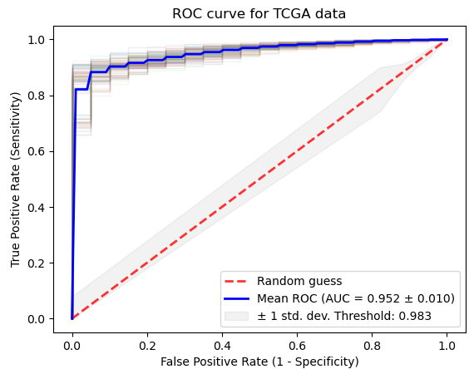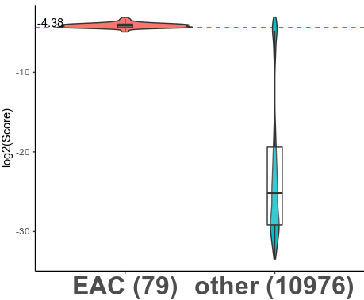
Figure avqxy29G Performance of six genes tissue-specific biomarker in TCGA discovery cohort for predicting EAC and other types of cancers by SVM classifier. Left: ROC curve Right Boxplot

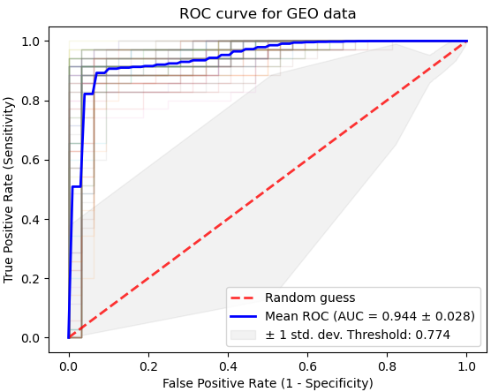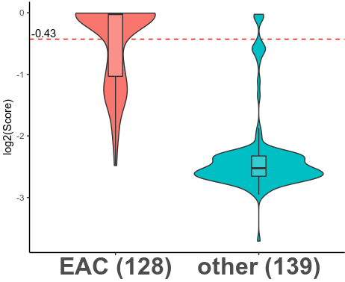
Figure Au8hgYSz Performance of six genes tissue-specific biomarker in GEO validation cohort for predicting EAC and other types of cancers by SVM classifier. Left: ROC curve Right Boxplot

Table 2 Performance of MODY function module on discovery and validation cohort
Cohort | Sensitivity | Specificity | AUC | F1 Score | P-value  (Fisher exact test)
Discovery (TCGA) | 94.9% | 93.2% | 0.952 | 0.165 | 1.46x10⁻⁸⁰
Validation (GEO) | 97.6% | 89.9% | 0.944 | 0.936 | 2.17x10⁻⁵⁵

Discussion
Previously many researchers have studied the biomarker of early-stage diagnosis or survival for EAC patients. It had revealed a variety of biomarkers associated with histology type between EAC or ESCC and their matched normal esophageal tissue ([10.3892/ol.2019.10808], [10.1016/j.prp.2019.04.018], [10.1038/s41598-018-27307-2], [10.1136/bmjopen-2015-008653], [10.1016/j.prp.2019.152638]). But so far there is no universal tissue-specific biomarkers identified for EAC cases. Early-stage diagnosis and prognosis analysis can not take effect simultaneously neither. The reason could be partially attributed that the most of previous TGCA mining study is started from gene screening. Such screening was usually based on a priori association between single gene expression with expected clinic features (most likely survival time) followed by feature selection technology such as step-wise model selection by stepAIC in R package MASS [ISBN:0-387-95457-0]. For example in ref [10.3892/ol.2019.10808 ] first researchers applied kaplan-Meier survival estimate to all lncRNAs and final got 26 survival-related RNA, then lncRNA-regulated ceRNA network for EAC was constructed from them. While in ref [10.1016/j.biopha.2019.108655], author also searched all possible genes at first and then got 73 OS-related functional lncRNAs. Finally DLEU2 gene was filtered out as a marker. Those methods usually have two drawbacks. Firstly according to data summary of TCGA cohort there are approximately 40,000 genes measured for mRNA expression therefore depending on the p-value cutoff applied in researches (0.01 or even higher 0.05) there would be 400-2000 "survival-related" genes as false positive. In fact by simple univariate cox proportional hazards regression one can identify more than 1,000 "survival-related" genes in TCGA project ESCC (p-value < 0.01) but after applying a strict p-value adjustment [10.1111/j.1467-9868.2010.00746.x] no single gene was capable statistically as a solo prognosis biomarker (data not shown). So a model merely based on a priori association between single expression and survival could easily fall into overfitting. The second problem is that step-wise feature selection might silently introduce other non-survival-related variable in the same order which would further lead to unexpected results such as biased R-square value, falsely narrow confidence interval and biased P-value [10.17485/ijst/2018/v12i6/139581]. Hereby we avoided from utilizing step-wise or all-possible-subset feature selection method to evade the forgoing drawbacks. The functional enrichment acted here as dimensional reduction and GSVA score involved in regression as variables. Hence we searched for survival-related pathways or functional modules instead of individual gene.

We firstly analyzed TCGA projects which contained the 79 EAC cases and 11055 cancer cases from other 33 projects to find the DEGs from the different cancer types. Altogether 4464 uniformly up-regulated DEGs were screened. To demonstrate the functional mechanism of common DEGs in EAC, we performed GO enrichment and KEGG/Reactome pathway enrichment analysis. The results of enrichment analysis displayed that the EAC up-regulated DEGs were mainly involved in the glycan processing pathway, cornification and diabetes such as O-linked glycosylation of mucins (HSA-913709), cornified envelope (GO0001533) and maturity onset diabetes of the young (MODY) (KEGG04950). Glycosylation especially for mucins sometime leads to adhesion of cell apical membrane, which enables cells to from a layer or network. While the genes in MODY pathway mainly involve in foregut endodermal epithelium differentiation. Six genes (HNF4G, HNF4A ,PDX1, NEUROG3, RFX6 and PAX4) were uniformly up-regulated in EAC. According to the gene expression correlation results HNF4A/G and PDX1 shared a similar expression pattern while NEUROG3, RFX6 and PAX4 correlated to each other in another one. Next instead of filtering out individual DEGs we used GSVA to calculate enrichment score of each function module or pathway. We screened out six genes as a poor-progonosis risk factor (HR 4.03) since it correlates with progonosis in univariate (p-value 0.043) and multivariate Cox regression (p-value 0.027). Finally we evaluated the performance six genes as a EAC universal histology biomarker (AUC 0.952) and verified them in an independent GEO dataset (AUC 0.944) by SVM classifier.

Although many studies had been done to probe the origin of progenitor of EAC there was no consensus on the mechanisms of their occurrence or migration. Some have suggested that in humans, these columnar metaplastic cells, a well known precursor lesion of EAC, arise from esophageal submucosal glands [10.1016/j.bpg.2014.11.001]. But some research results are more compatible with the assumption that metaplastic epithelium was caused from a migration of intestinal stem cells into the damaged squamous regions [10.1016/j.jcmgh.2017.03.009]. Interestingly we found that the six genes uniformly up-regulated in EAC were also key regulators of or related to the differentiation of prepatterned endodermal epithelium of foregut cells [10.1210/en.2004-157, 10.1136/gut.2003.026609, 10.1038/nature08748]. So we presumed that the EAC progenitor cells are multi-originated. The up-regulation of six MODY pathway genes including PDX1 indicated that the jejunal progenitor cells can migrate to esophageal surface after esophageal was damaged by gastric acid reflux, hot food, alcohol etc. On the other hand the enrichment of glycosylation of mucins containing MUC5AC MUC6 genes (gastric mucin markers) [10.1016/j.jcmgh.2018.06.007] suggested gastric epithelial cells were also involved in intestinal metaplasia of EAC.

In summary, we found that EAC up-regulated DEGs were mainly involved in the glycan processing pathway and diabetes. We also identified six genes (HNF4G, HNF4A ,PDX1, NEUROG3, RFX6 and PAX4) in MODY pathway as a poor-progonosis risk factor. It associated with progonosis in univariate (p-value 0.043) and multivariate Cox regression (p-value 0.027). It can also perform as a universal EAC histology biomarker. This result support the "migration-differentiation" model that the migration of foregut stem cells into the damaged squamous tissue and the polarization process of stem cells could be a possible mechanism of EAC.

